BDA400 - Data Science Tools and Techniques
Assignment 2 Report
Technical Analysis using R, Preliminary Stage
Student: Sodiq Yunusa
GitHub repository: https://github.com/SodiqYunusa/TechnicalAnalysis
Files: portfolio.txt, stock_functions.R, display_stocks.R (all in the Assignment2 folder of the repository)

1. Overview
This report documents the first stage of the three-part Technical Analysis project. It covers setting up the tools (GitHub, Git, R, RStudio and R packages), creating the portfolio file, and writing R functions that import stock data, calculate basic statistics and display the results with charts. Each step below explains what was done and includes screenshots of the step.
Requirement | Where it is covered | Deliverable
GitHub account and repository | Section 2 | Repository TechnicalAnalysis
R and RStudio installation | Sections 3 and 4 | Screenshots
R packages installation | Section 5 | Screenshots
Project configuration (portfolio.txt) | Section 6 | portfolio.txt
Function to import stock data | Section 7 | stock_functions.R
Function to compute statistics | Section 8 | stock_functions.R
Display of data and visualizations | Section 9 | display_stocks.R, plots folder
Documentation | This report | Word report

2. GitHub Account and Repository

2.1 Create the GitHub account
- Open github.com/signup.
- Enter an email address, a password and a username (SodiqYunusa), then select the country.
- Complete the verification, then sign in with the new account.
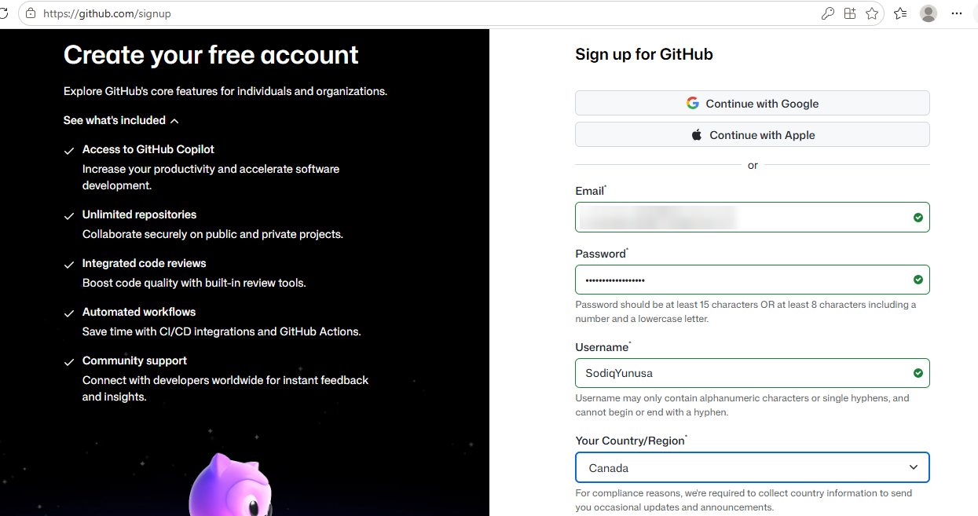
Figure 1. GitHub sign-up page (email address hidden).
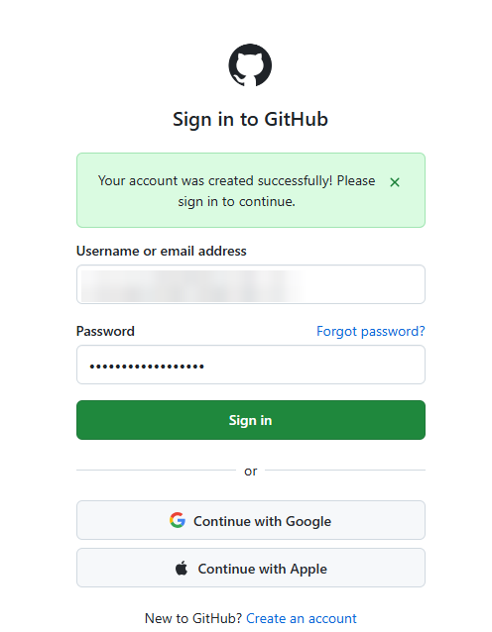
Figure 2. Account created successfully; sign-in page (email address hidden).
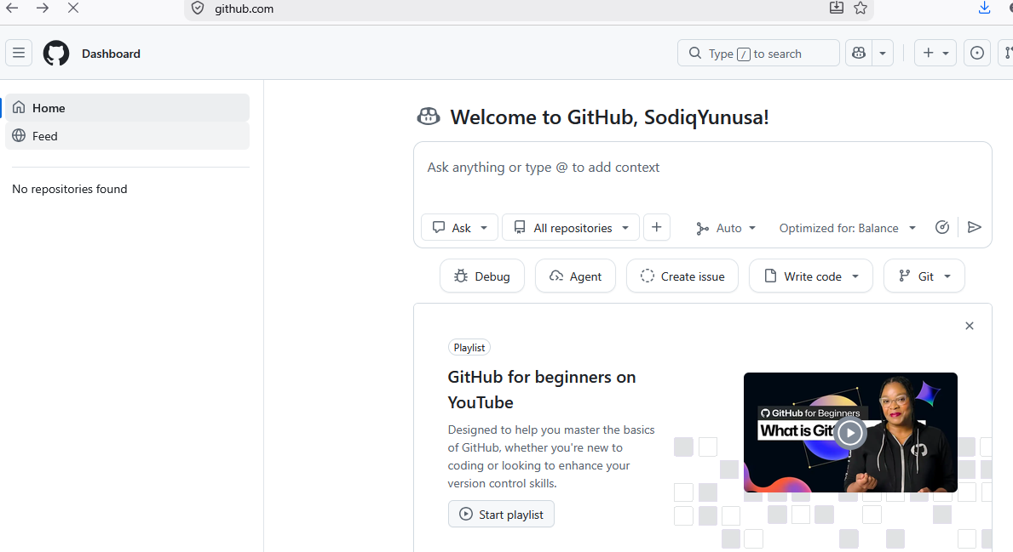
Figure 3. GitHub dashboard after signing in: "Welcome to GitHub, SodiqYunusa!"

2.2 Install and configure Git
Git for Windows (version 2.56.0) was installed using the setup wizard. The screens below show each step and the option chosen.
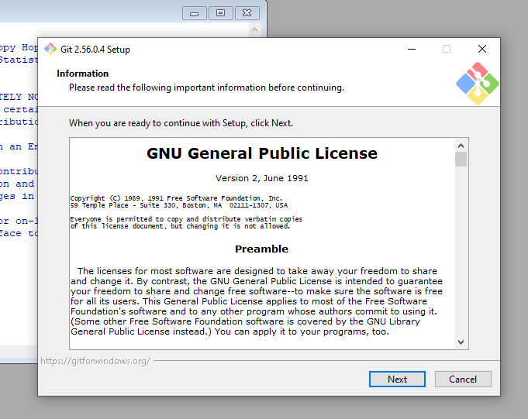
Figure 4. Git setup: license information.
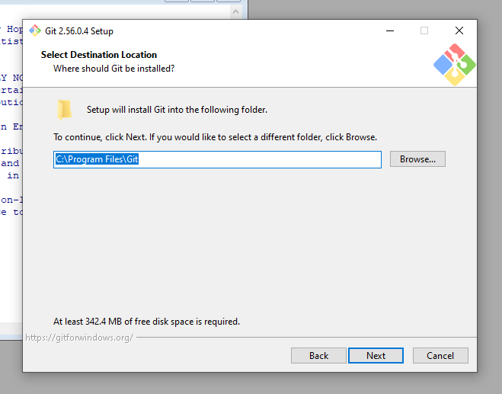
Figure 5. Git setup: installation location (default).
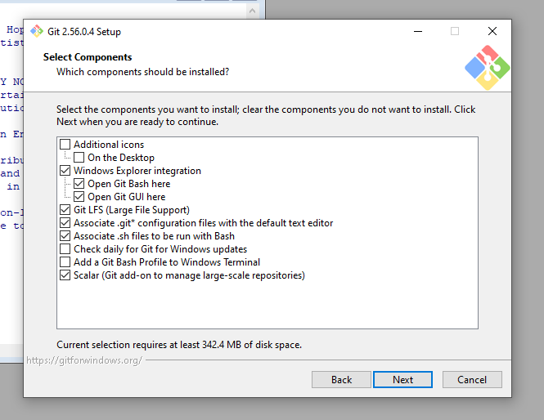
Figure 6. Git setup: components to install.
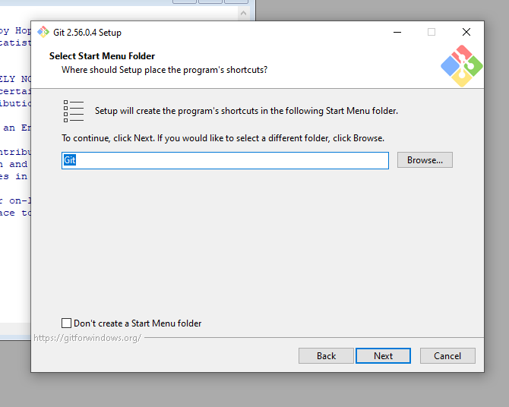
Figure 7. Git setup: Start Menu folder.
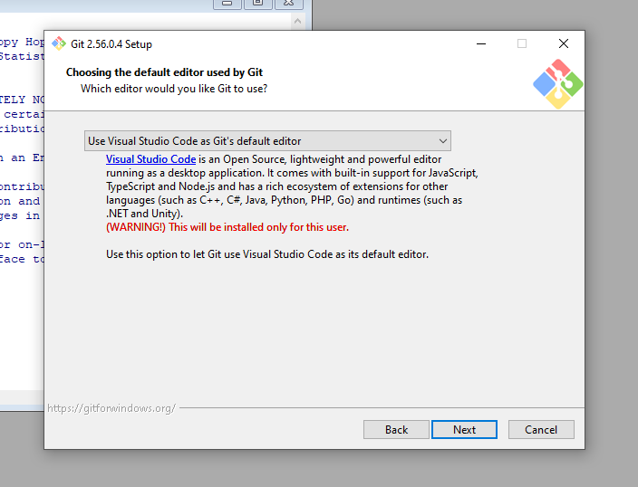
Figure 8. Git setup: default editor set to Visual Studio Code.
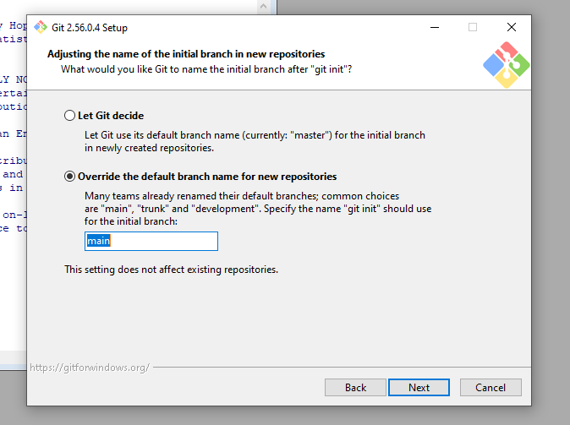
Figure 9. Git setup: initial branch name for new repositories set to "main".
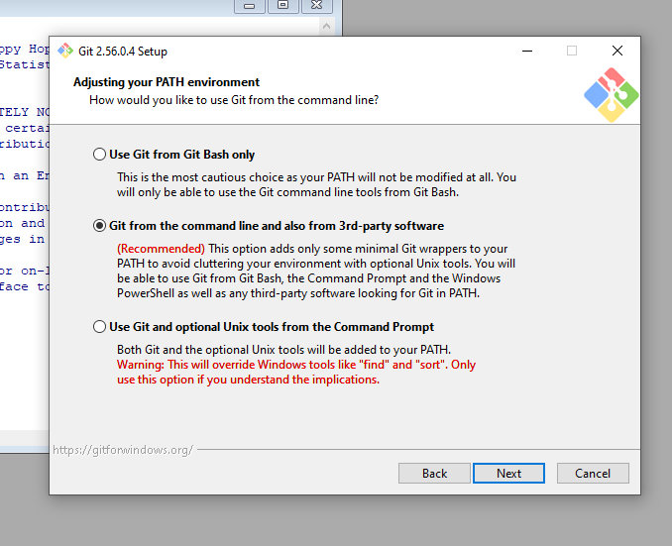
Figure 10. Git setup: PATH environment, "Git from the command line and also from 3rd-party software" (recommended).
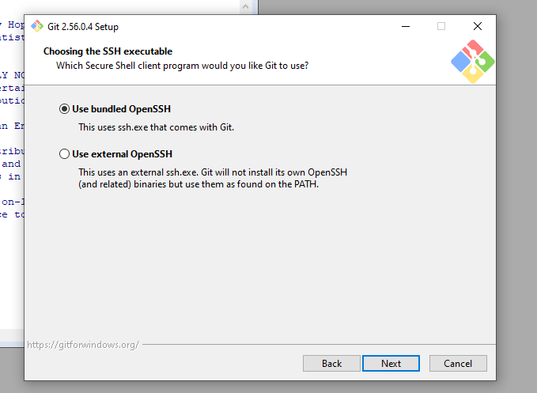
Figure 11. Git setup: SSH executable, bundled OpenSSH.
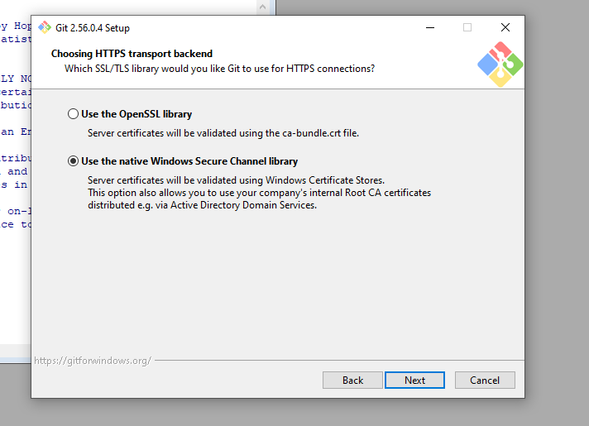
Figure 12. Git setup: HTTPS transport backend, native Windows Secure Channel library.
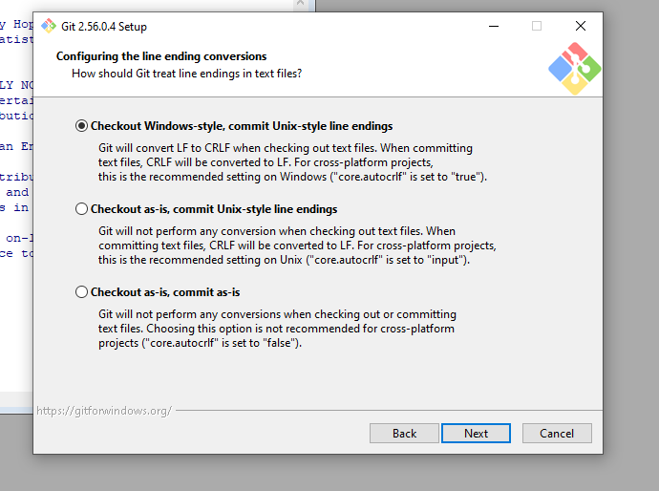
Figure 13. Git setup: line ending conversions (Windows-style checkout, Unix-style commit).
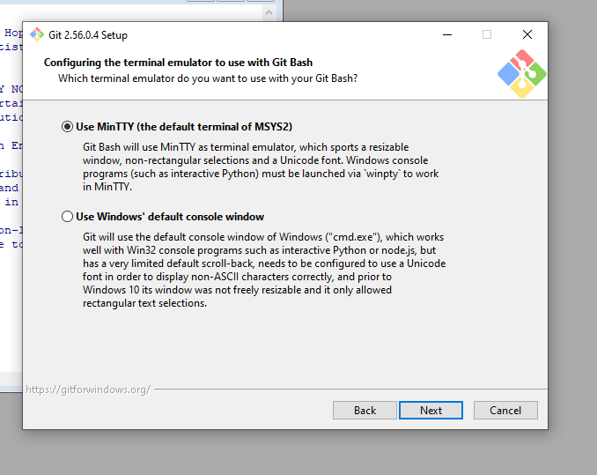
Figure 14. Git setup: terminal emulator, MinTTY.
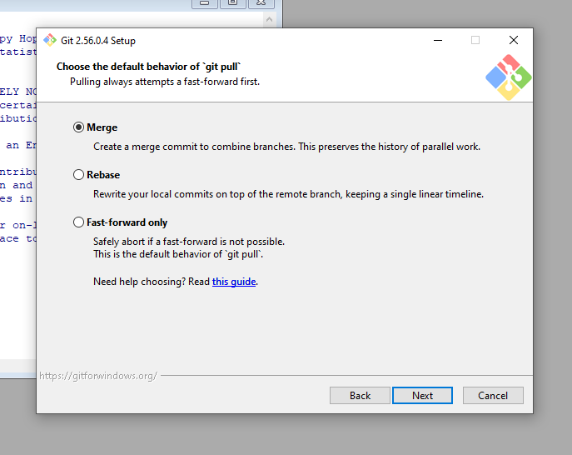
Figure 15. Git setup: default behavior of "git pull", Merge.
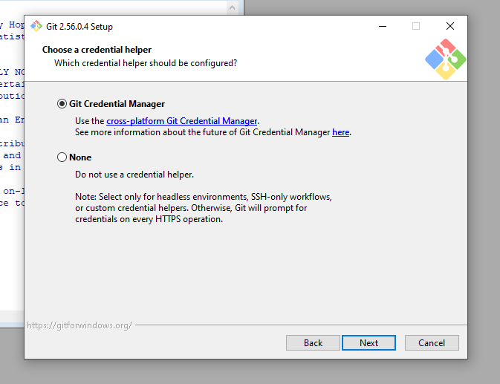
Figure 16. Git setup: credential helper, Git Credential Manager.
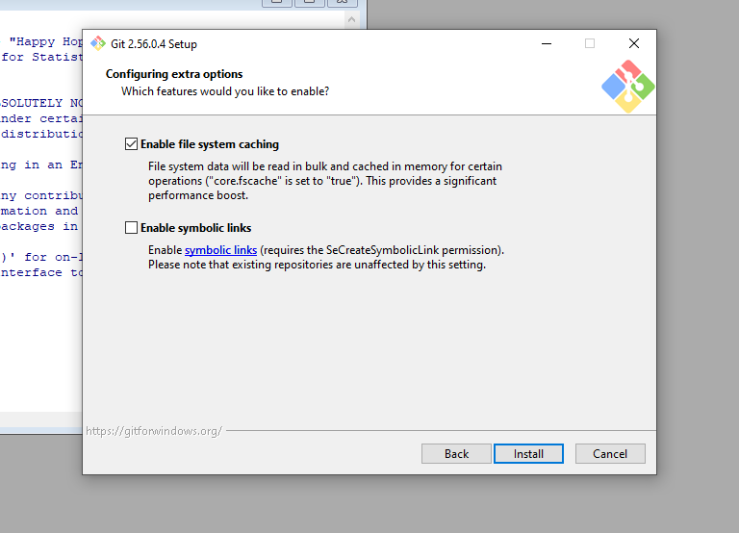
Figure 17. Git setup: extra options, file system caching enabled.
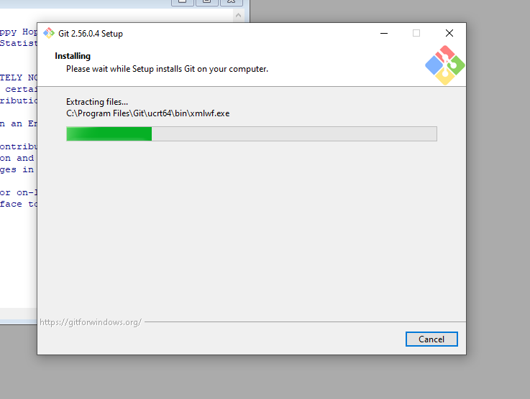
Figure 18. Git setup: installation in progress.
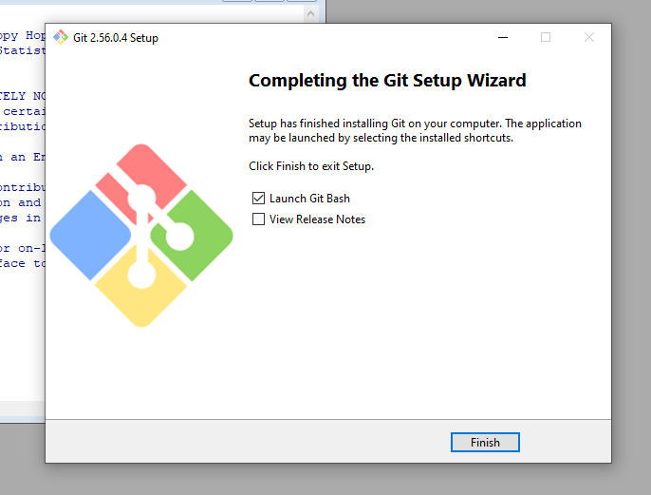
Figure 19. Git setup: installation complete.
After the installation, git --version was run in Command Prompt to confirm that Git works, and the user name and email were configured with git config --global user.name and git config --global user.email.
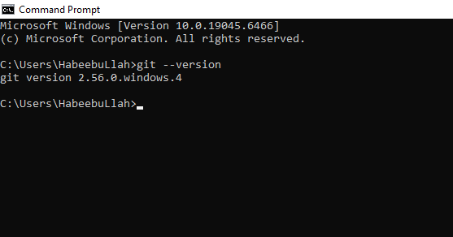
Figure 20. Command Prompt: git --version shows git version 2.56.0.windows.4.
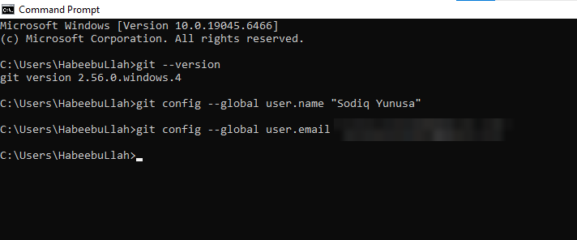
Figure 21. Command Prompt: git config commands for the user name and email (email address hidden).

2.3 Create the TechnicalAnalysis repository
- On github.com click the + icon (top right) and choose New repository.
- Enter the repository name TechnicalAnalysis, set the visibility to Public, and create the repository.
- Add a README.md file through Add file > Create new file, type a one-line description and click Commit changes.
Correction made during setup: the repository was first created with a stray trailing character in its name, which GitHub turned into a hyphen (TechnicalAnalysis-), as the first screenshots below show. This was noticed before any files were cloned and fixed under Settings > General > Repository name, so the final name matches the assignment exactly (the clone command in Section 2.4 uses the corrected name).
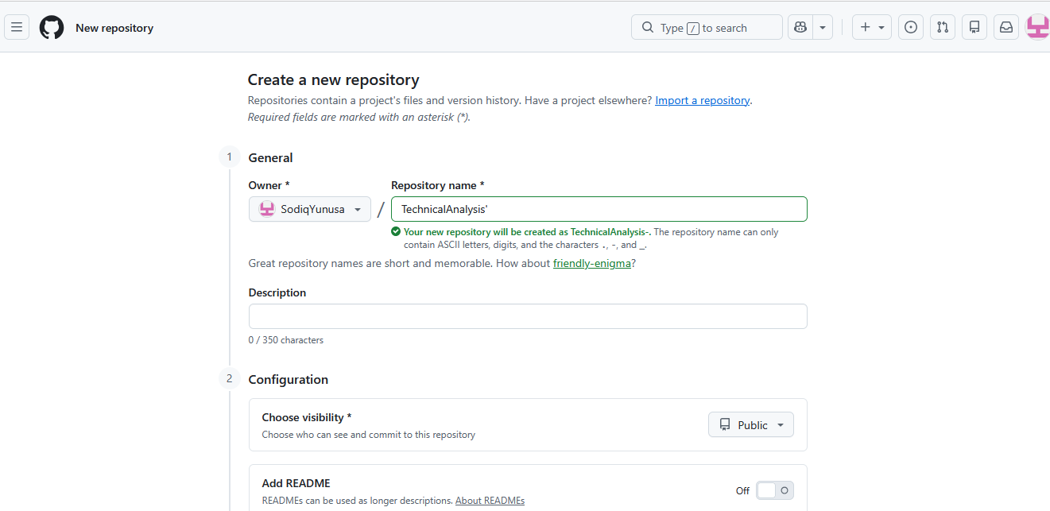
Figure 22. New repository form.
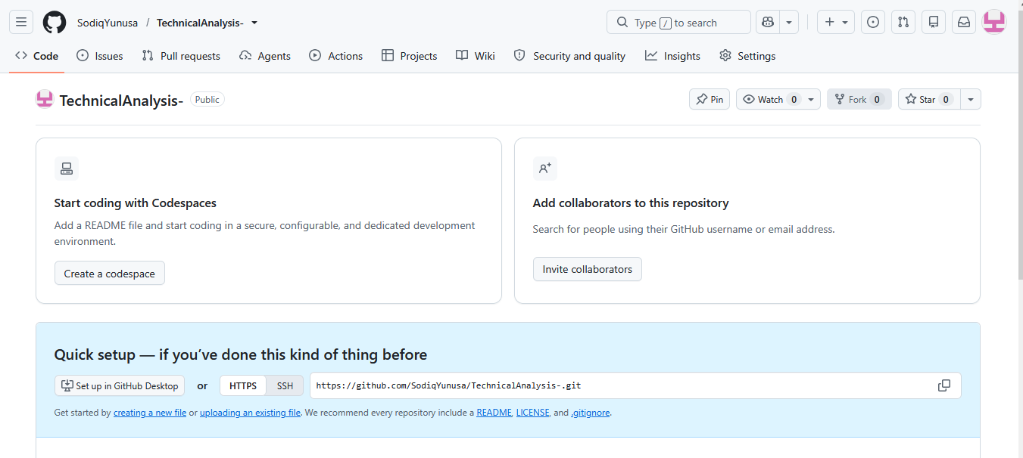
Figure 23. Repository page right after creation (name shows the stray hyphen).
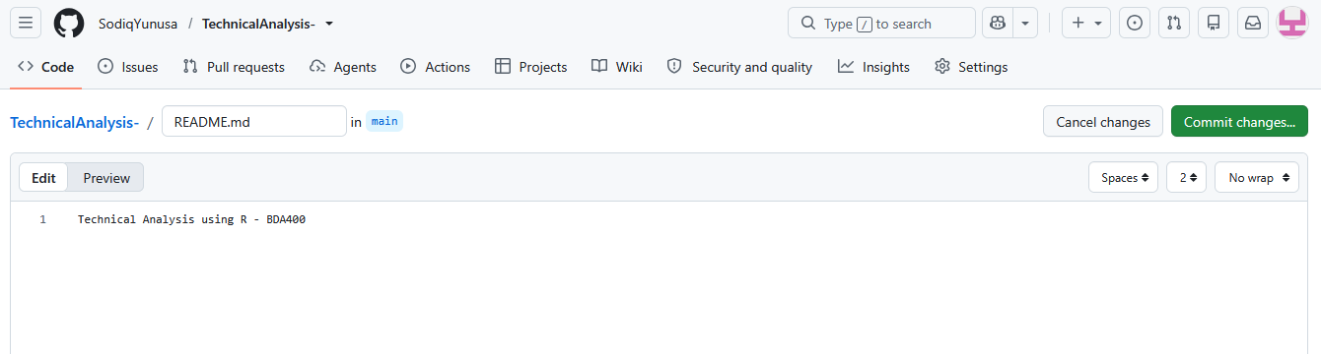
Figure 24. Creating README.md through the GitHub web editor.
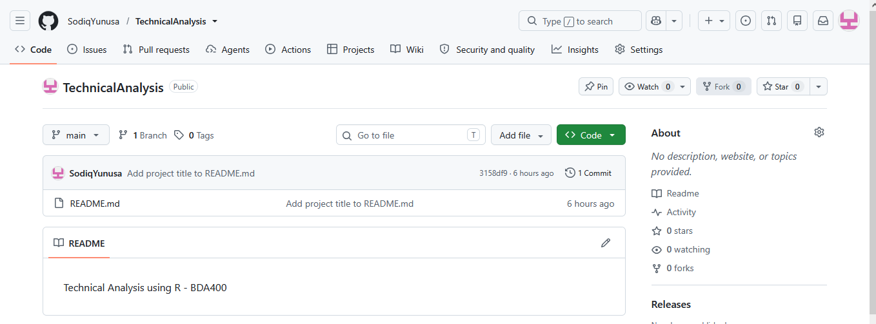
Figure 25. Repository page showing README.md and the first commit.

2.4 Clone the repository and create the folder structure
- On the repository page click the green Code button, choose HTTPS and copy the link.
- In Command Prompt run cd Documents and then git clone https://github.com/SodiqYunusa/TechnicalAnalysis.git.
- In File Explorer open Documents > TechnicalAnalysis and create a subfolder named Assignment2. One subfolder is used per assignment.
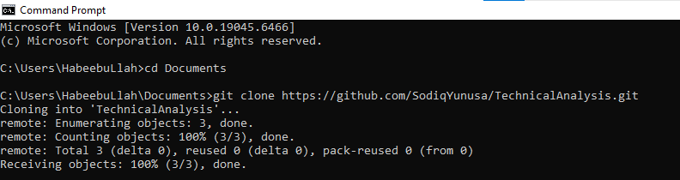
Figure 26. Command Prompt: cloning the TechnicalAnalysis repository.
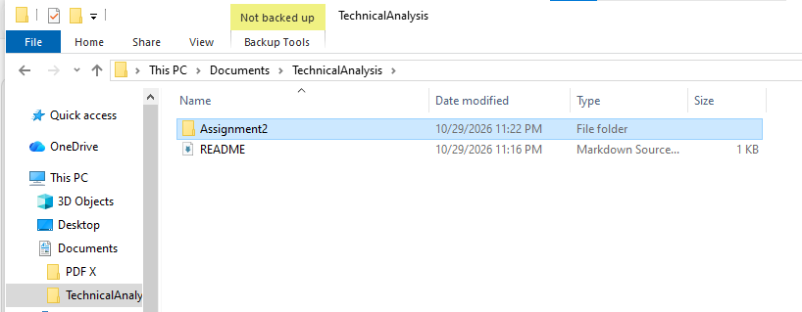
Figure 27. File Explorer: the cloned TechnicalAnalysis folder containing README and the new Assignment2 folder.

3. Installing R
- Go to cran.rstudio.com and choose Download R for Windows, then base, and download the Windows installer (R 4.6.1 was installed).
- Run the R installer, choose English as the setup language, and accept the defaults on the remaining screens.
- Open R once after the installation to confirm that it starts and shows the version.
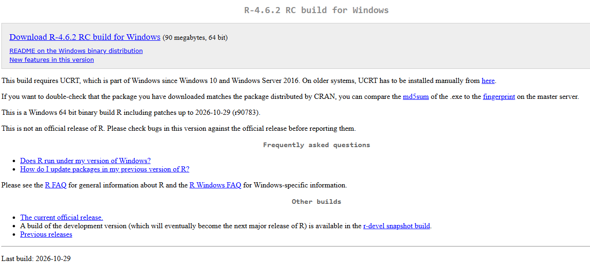
Figure 28. CRAN download page for R for Windows.
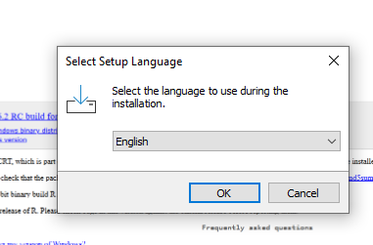
Figure 29. R setup: language selection.
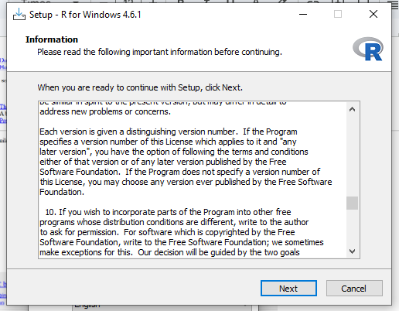
Figure 30. R setup: information (license).
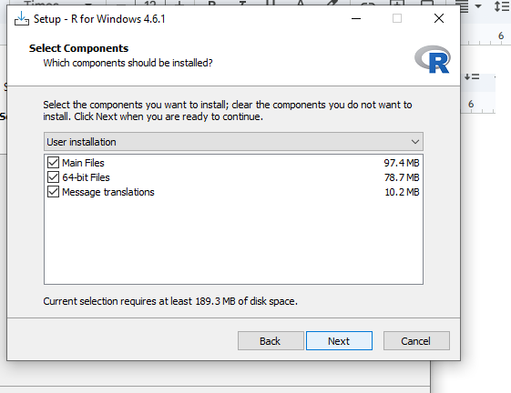
Figure 31. R setup: select components (user installation).
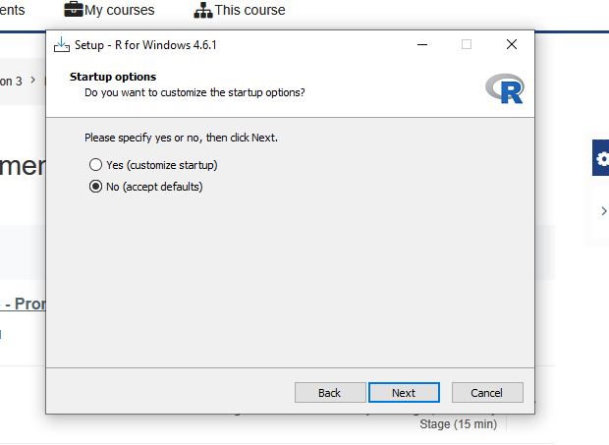
Figure 32. R setup: startup options (defaults).
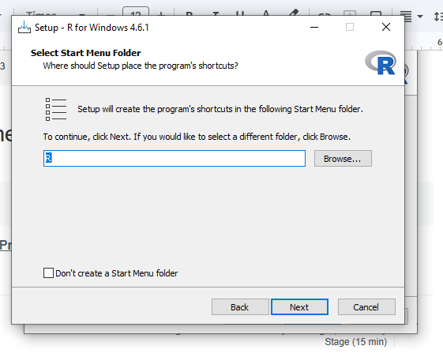
Figure 33. R setup: Start Menu folder.
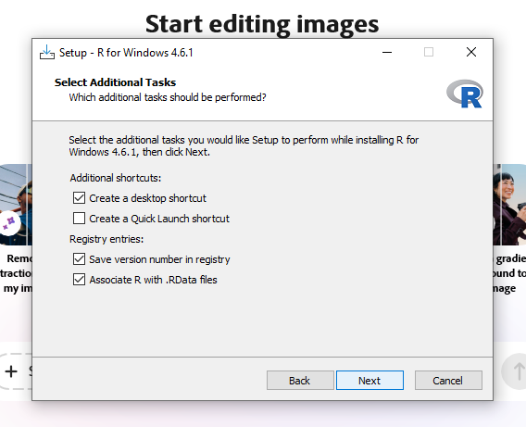
Figure 34. R setup: additional tasks (desktop shortcut, registry entries).
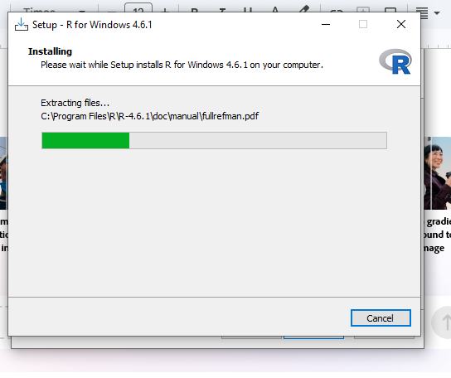
Figure 35. R setup: installation in progress.
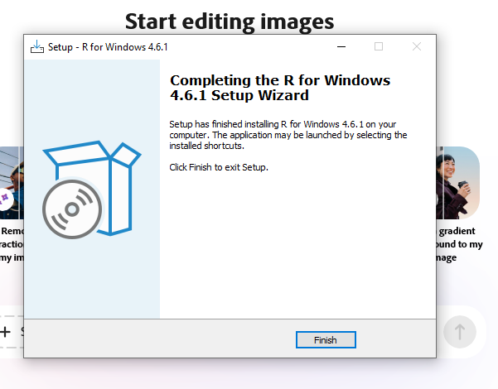
Figure 36. R setup: installation complete.
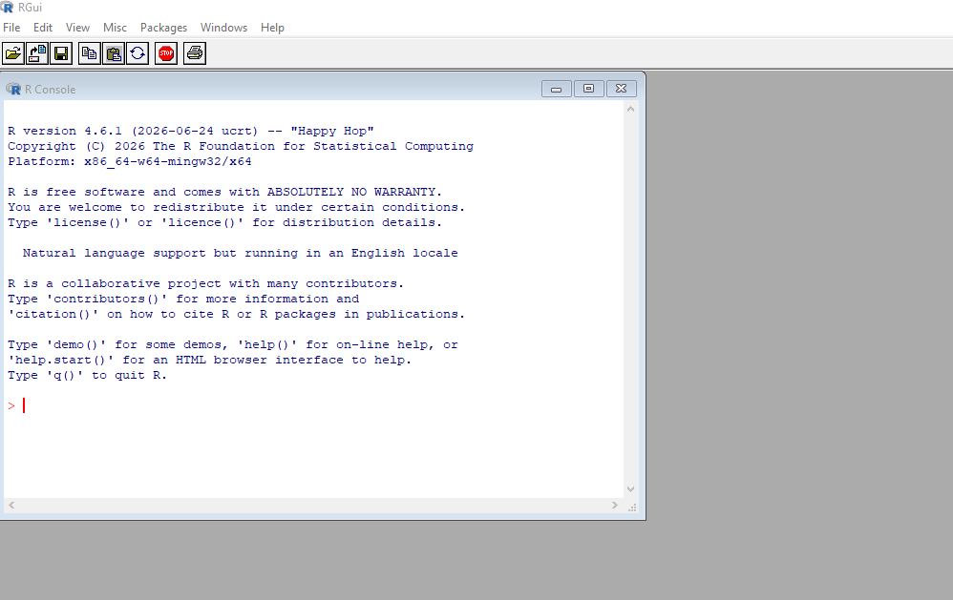
Figure 37. R console (RGui) after installation, showing R version 4.6.1.

4. Installing RStudio
- Download RStudio Desktop for Windows from the Posit website (posit.co/download/rstudio-desktop).
- Run the installer, keep the default install location, and click Install.
- Click Finish, then open RStudio. The Console shows the R version, confirming that RStudio found the R installation (shown in the first screenshot of Section 5).
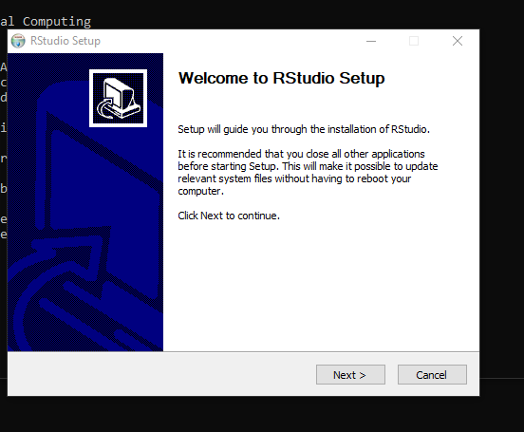
Figure 38. RStudio setup: welcome screen.
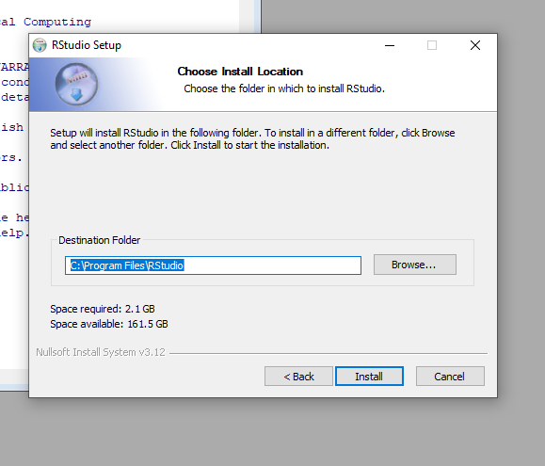
Figure 39. RStudio setup: install location (default).
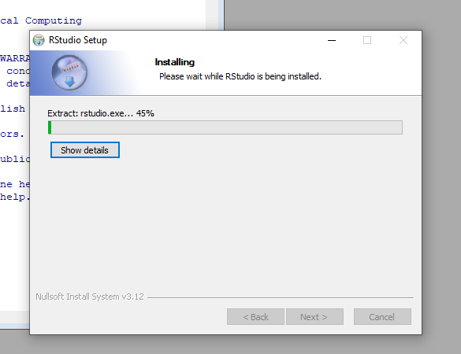
Figure 40. RStudio setup: installation in progress.
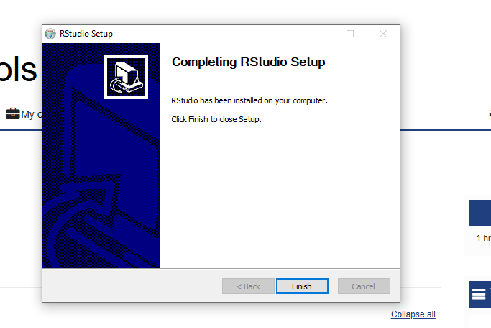
Figure 41. RStudio setup: installation complete.

5. Installing the R Packages
Two packages are needed for this stage:
- quantmod: downloads historical market data (getSymbols) and draws financial charts (chartSeries).
- TTR (Technical Trading Rules): provides indicator functions such as the simple moving average, SMA().
They were installed from the RStudio Console:
install.packages(c("quantmod", "TTR"))

R also installed the dependencies xts, zoo, curl and jsonlite automatically. R printed a warning that Rtools was not installed. Rtools is only needed to compile packages from source code; these packages were installed as ready-made Windows binaries ("successfully unpacked and MD5 sums checked"), so the warning can be ignored. The installation was then verified by loading both packages:
library(quantmod)
library(TTR)

Both packages loaded without errors. The messages about masked objects (as.Date) and a registered S3 method are normal start-up notes from quantmod and zoo.
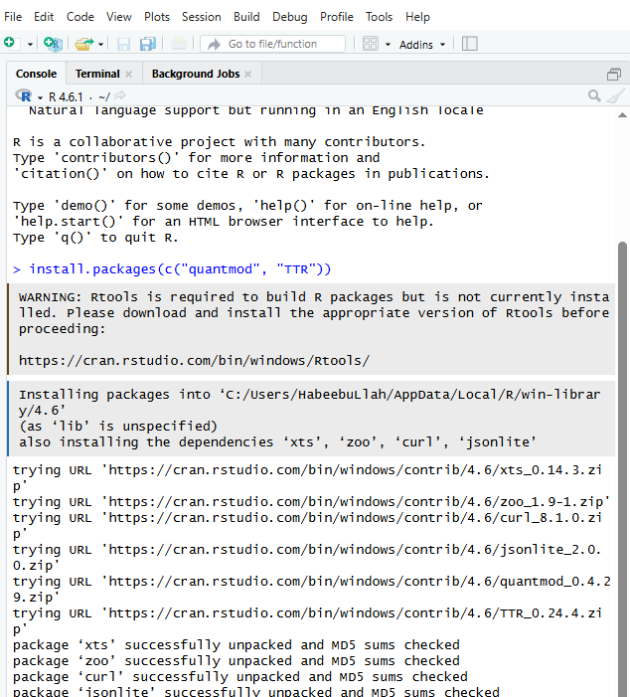
Figure 42. RStudio Console: install.packages(c("quantmod", "TTR")), including the Rtools warning and the successful package installation. The R version (4.6.1) is shown in the Console header.
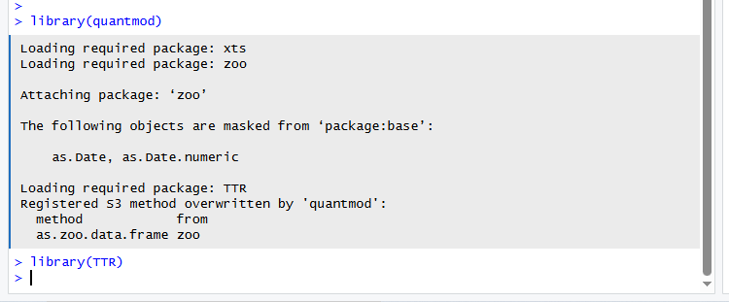
Figure 43. RStudio Console: library(quantmod) and library(TTR) load with no errors.

6. Project Configuration: portfolio.txt
The portfolio is stored in a plain text file named portfolio.txt, with one stock symbol per line. The six symbols were chosen to cover five different sectors, so the later analysis compares stocks that behave differently:
Symbol | Company | Sector
AAPL | Apple Inc. | Technology
MSFT | Microsoft Corporation | Technology
JPM | JPMorgan Chase & Co. | Financials
JNJ | Johnson & Johnson | Healthcare
XOM | Exxon Mobil Corporation | Energy
KO | The Coca-Cola Company | Consumer staples

Contents of portfolio.txt:
AAPL
MSFT
JPM
JNJ
XOM
KO

Symbols can be added or removed by editing the file; the functions read it every time they run, so no code changes are needed. The list.files() output in Section 7 confirms that portfolio.txt is in the Assignment2 folder.

7. Function for Importing Stock Data
File: stock_functions.R. Main function: load_stock_data()
load_stock_data() reads portfolio.txt and imports the price history of every symbol with quantmod. By default it downloads the last two years of daily data from Yahoo Finance. The work is split into small functions:
Function | What it does
read_portfolio() | Reads portfolio.txt, trims spaces, converts symbols to upper case, and ignores blank lines, lines starting with # and duplicates.
fetch_one_symbol() | Downloads one symbol with quantmod::getSymbols(). The data source is isolated in this one function.
xts_to_data_frame() | Converts the xts object from quantmod into an ordinary data frame with the columns Date, Open, High, Low, Close, Volume and Adjusted, and removes days with no closing price.
load_stock_data() | Loops over the symbols and returns a named list holding one data frame per symbol (for example stocks$AAPL). It also creates a separate variable for each (AAPL_df, MSFT_df, ...), which appear in the Environment pane.

Error handling: each symbol is imported inside tryCatch(). If one symbol fails (a typing mistake in the ticker or a network problem), a message is printed, the remaining symbols are still imported, and a warning at the end lists the symbols that failed.
Usage:
stocks <- load_stock_data("portfolio.txt")
names(stocks) # "AAPL" "MSFT" "JPM" "JNJ" "XOM" "KO"
head(stocks$AAPL) # first rows of the Apple data frame

The screenshot below shows list.files() confirming that the three files are in the Assignment2 folder (display_stocks.R, portfolio.txt and stock_functions.R), followed by the script running and importing all 6 of 6 symbols.
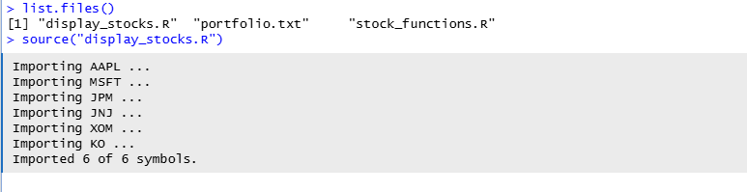
Figure 44. RStudio Console: list.files() and source("display_stocks.R"); all 6 of 6 symbols imported.

8. Function for Computing Statistics
File: stock_functions.R. Main function: calculate_statistics()
calculate_statistics() takes one stock's data frame and returns a one-row data frame of statistics for the closing price. calculate_all_statistics() applies it to every stock and stacks the rows into one summary table, which is a structured format that is easy to display or export.
Statistic | How it is calculated
Moving average (SMA20) | Simple moving average of the last 20 closing prices, using TTR::SMA(). The latest value is reported. The period can be changed with the ma_period argument.
Mean | Sum of the closing prices divided by the number of days, using mean().
Median | The middle closing price, using median().
Mode | Base R has no function for the statistical mode, so stat_mode() was written. Prices are continuous, so they are rounded to 2 decimals and the most frequent value is returned. If several values tie, the lowest is returned, and ModeCount shows how many times it occurs.
Standard deviation | Sample standard deviation of the closing prices, using sd().
Also reported | Number of observations, start and end dates, latest close, and CV_pct (standard deviation as a percentage of the mean, which allows stocks with different price levels to be compared).

The moving average, mean, median and standard deviation come from base R and TTR, and the mode comes from the custom function. The function also checks its input: it stops with a clear message if the data frame has no Close column, and returns NA for the moving average (with a warning) if there are fewer observations than the moving average period.
Usage:
stats_df <- calculate_all_statistics(stocks)
print(stats_df)

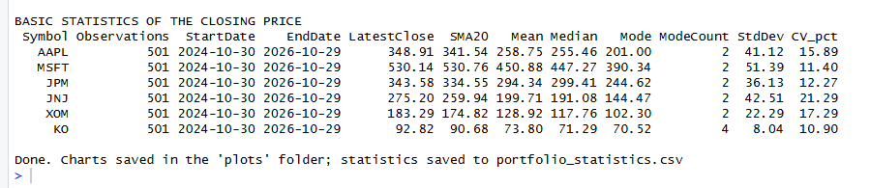
Figure 45. Statistics table for all six stocks: observations, date range, latest close, 20-day moving average, mean, median, mode, standard deviation and CV.

9. Display Utilities and Visualizations
File: display_stocks.R
Stock data can be presented in several ways, as on Yahoo Finance: a quote table, raw price history, and charts. The script provides one utility for each.
Function | Output
display_stock_data() | For one stock: header (symbol, number of trading days, date range), the first and last rows of the data frame, and its structure.
display_quote_summary() | A Yahoo-Finance-style quote table with one row per stock: latest close, change and percentage change, day low/high, 52-week low/high and volume.
display_statistics() | The statistics table, rounded to two decimals.
plot_price_chart() | Closing price with 20-day and 50-day moving averages, and a volume panel below.
plot_candlestick() | Candlestick chart of the last 90 trading days with volume and a 20-day average (quantmod::chartSeries).
plot_distribution() | Histogram of closing prices with the mean, median and mode marked, which shows what the three statistics mean visually.
plot_statistics_comparison() | Bar charts comparing mean vs median and standard deviation across the portfolio.

Running display_stocks.R imports the data, calculates the statistics, prints all of the displays above, draws every chart in the RStudio Plots pane, and saves a PNG copy of each chart in a plots folder. It also saves the statistics table as portfolio_statistics.csv. The results for the first stock (AAPL) are shown below. The data frames of the other five stocks and their price charts are in the appendices.
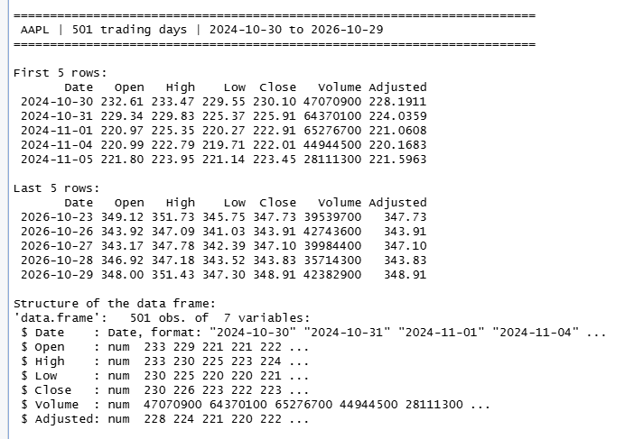
Figure 46. display_stock_data() for AAPL: header, first and last five rows, and structure of the data frame (501 trading days).
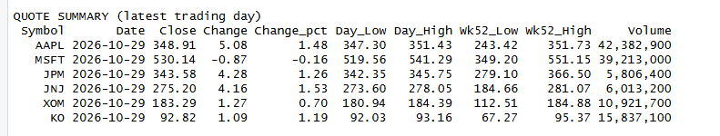
Figure 47. Quote summary (latest trading day) for all six stocks.
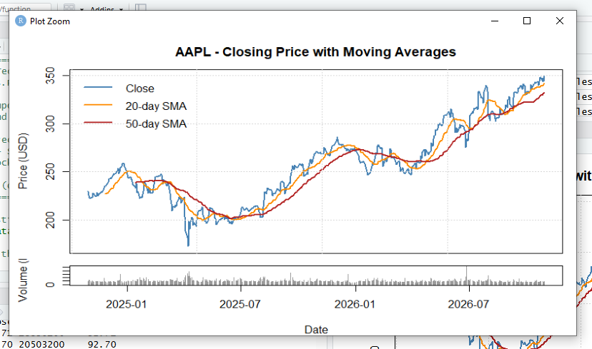
Figure 48. AAPL closing price with 20-day and 50-day moving averages, and daily volume.
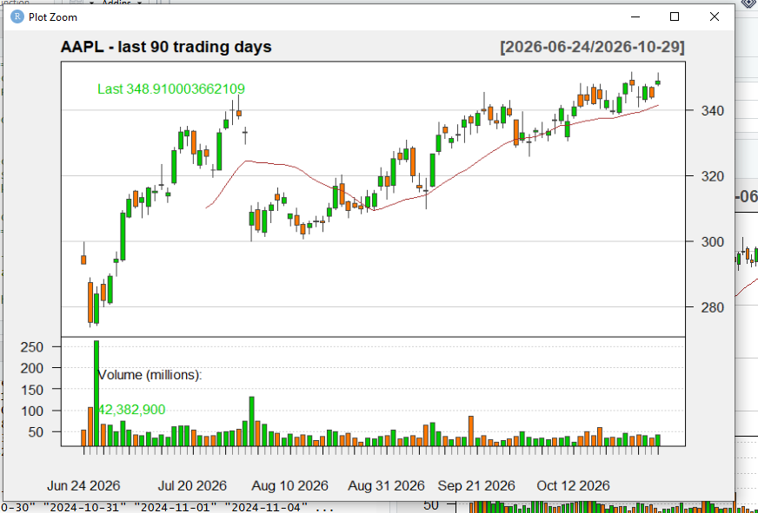
Figure 49. AAPL candlestick chart of the last 90 trading days, with volume and a 20-day average.
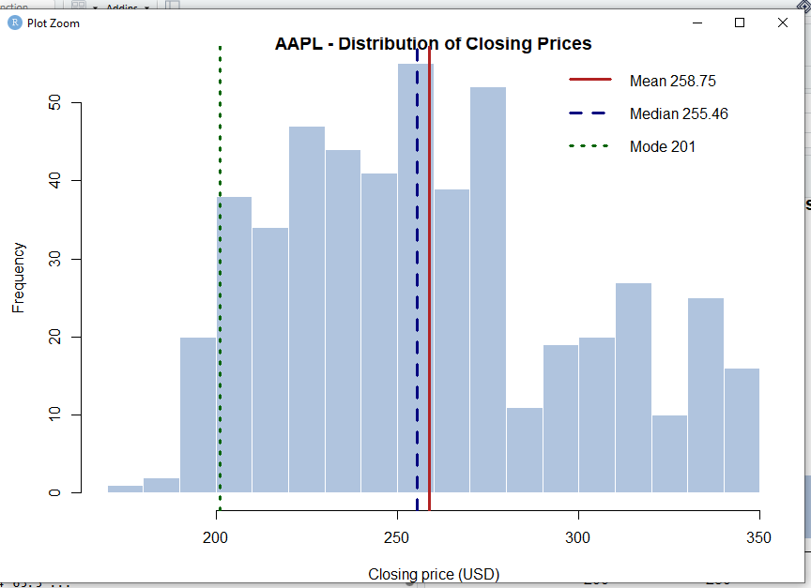
Figure 50. AAPL distribution of closing prices, with the mean (258.75), median (255.46) and mode (201) marked.
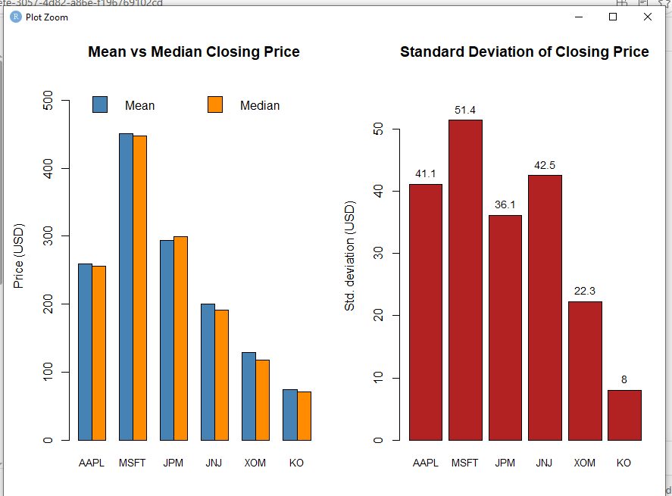
Figure 51. Mean vs median closing price, and standard deviation of the closing price, for all six stocks.

10. How to Run the Code
- Make sure R, RStudio and the quantmod and TTR packages are installed (Sections 3 to 5) and the computer is connected to the internet.
- Open RStudio and open display_stocks.R from the Assignment2 folder (File > Open File).
- Set the working directory to the script's folder: Session > Set Working Directory > To Source File Location. portfolio.txt must be in this folder. (Alternatively, run setwd("~/TechnicalAnalysis/Assignment2") in the Console.)
- Click Source, or run source("display_stocks.R") in the Console. This loads stock_functions.R automatically and produces all outputs.
- To use the functions on their own: source("stock_functions.R"), then stocks <- load_stock_data() and calculate_all_statistics(stocks).

Troubleshooting
- Portfolio file not found: the working directory is wrong. Repeat step 3.
- A symbol could not be imported: check the spelling of the ticker in portfolio.txt and the internet connection, then run again. Other symbols are not affected.
- Package not found: install it with install.packages("quantmod") and install.packages("TTR").

11. Repository Structure
TechnicalAnalysis/
README.md
Assignment2/
SodiqYunusa_BDA400_A02.docx (this report)
portfolio.txt
stock_functions.R
display_stocks.R
plots/ (PNG charts created by the script)
portfolio_statistics.csv (statistics table created by the script)

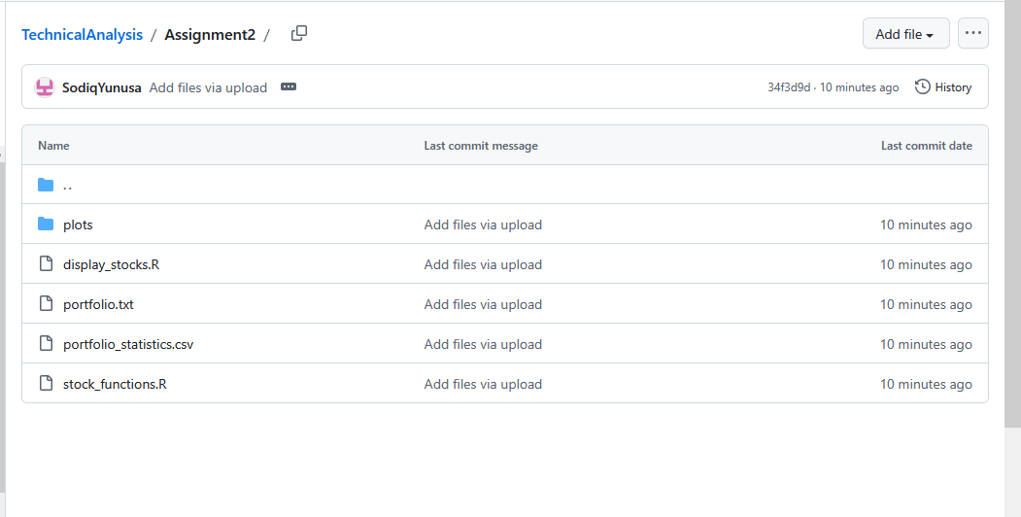

12. Testing
The functions were checked in the following ways:
- The mean, median, standard deviation and 20-day moving average returned by calculate_statistics() were compared with values computed directly with base R on the same price series, and matched.
- stat_mode() was tested on small vectors with a known answer, including a tie.
- read_portfolio() was tested with blank lines, comment lines, duplicate symbols, lowercase symbols and extra spaces.
- A symbol containing a hyphen (BRK-B) produced a valid variable name (BRK.B_df).
- A symbol that fails to import did not stop the other symbols from loading.
- A missing portfolio file, a data frame without a Close column, and a series shorter than the moving average period each produced a clear message instead of a crash.
- The complete script was run in RStudio on live data: all 6 of 6 symbols were imported (501 trading days each), and every table and chart was produced.

Appendix A. Data Frames of the Other Stocks
Output of display_stock_data() for the remaining five stocks in the portfolio.
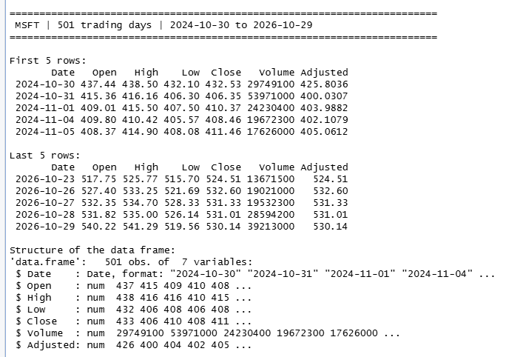
Figure 52. MSFT data frame display.
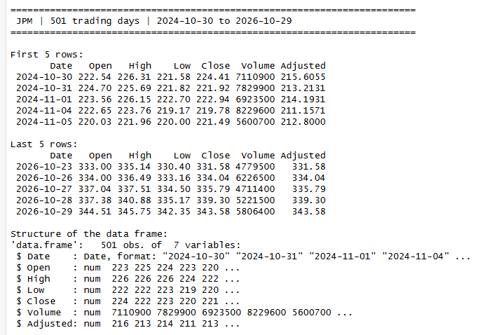
Figure 53. JPM data frame display.
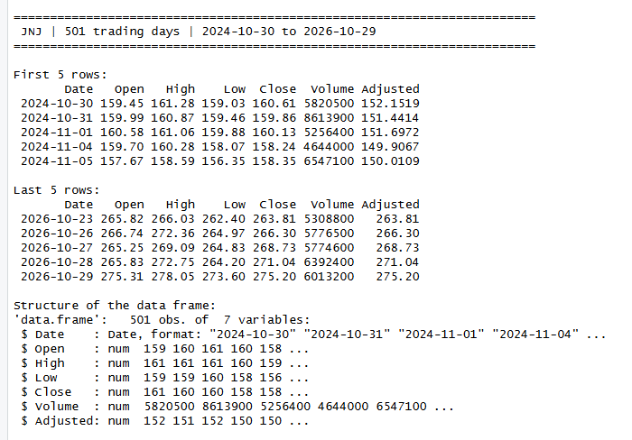
Figure 54. JNJ data frame display.
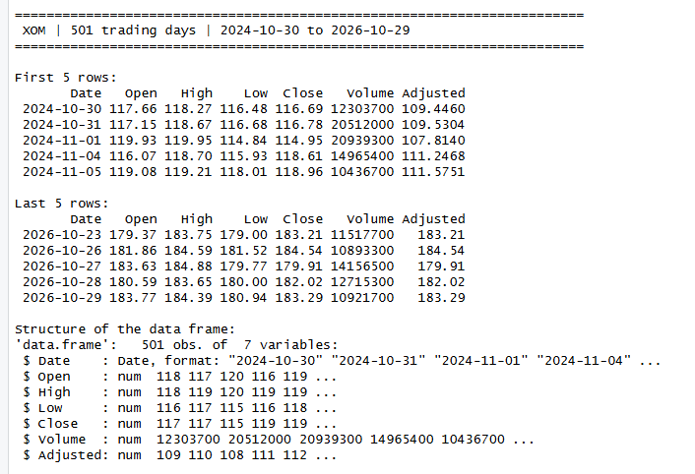
Figure 55. XOM data frame display.
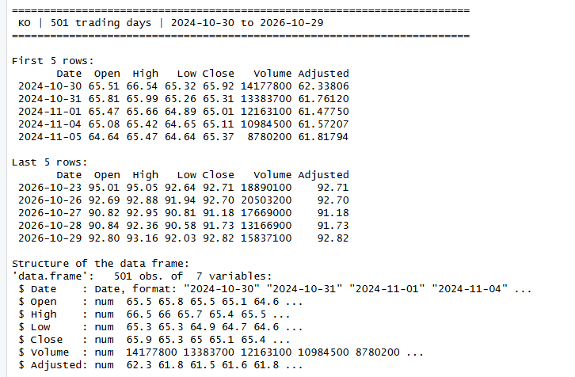
Figure 56. KO data frame display.

Appendix B. Price Charts of the Other Stocks
Output of plot_price_chart() for the remaining five stocks.
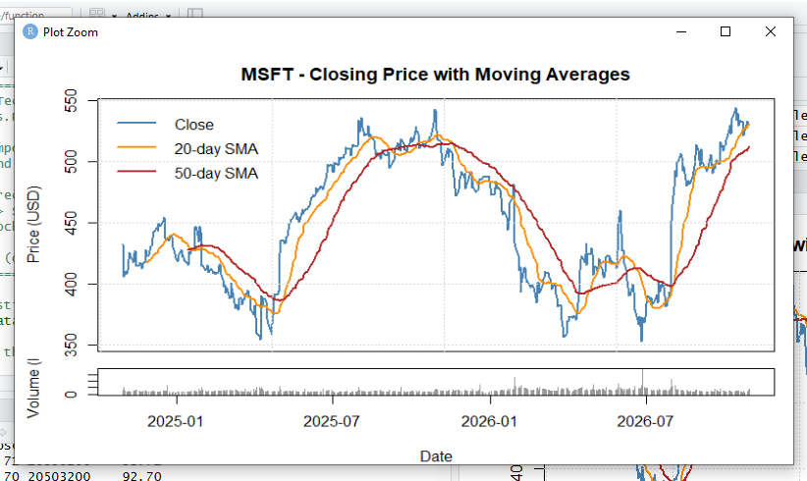
Figure 57. MSFT closing price with 20-day and 50-day moving averages.
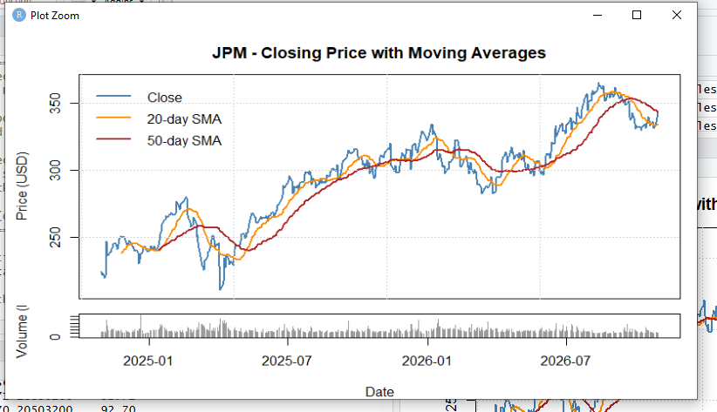
Figure 58. JPM closing price with 20-day and 50-day moving averages.
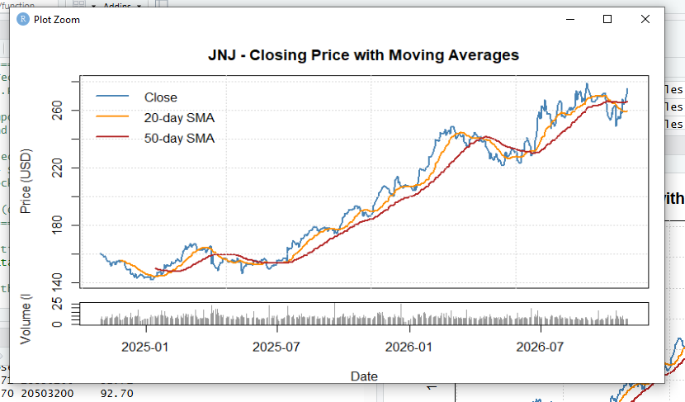
Figure 59. JNJ closing price with 20-day and 50-day moving averages.
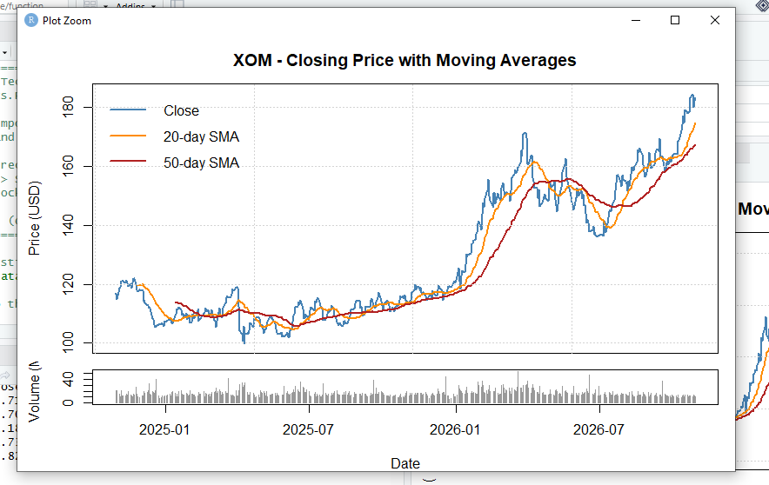
Figure 60. XOM closing price with 20-day and 50-day moving averages.
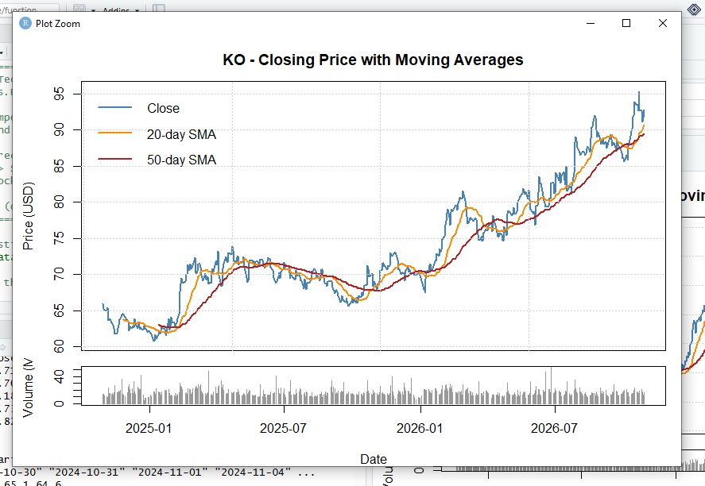
Figure 61. KO closing price with 20-day and 50-day moving averages.

